1) Create s3 bucket and upload some objects to s3.

* To create a bucket,

**Go to S3.**

**Click create bucket.**

**Type a name.**

**Select a region and Create.**

To upload some objects to s3  
S3 ---> Buckets ---> select the bucket ---> objects ---> upload ---> Add   
files ---> upload

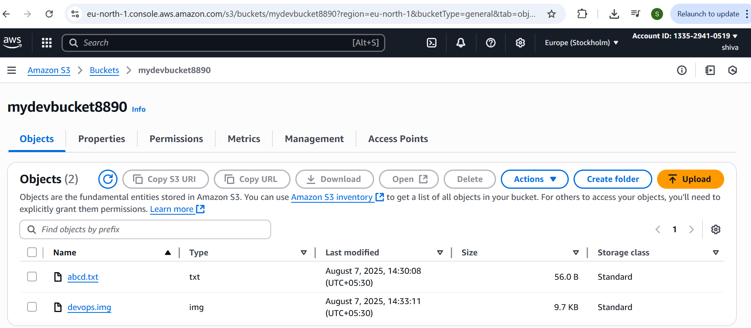

2) Deploy static website in s3 bucket.

S3 ---> Buckets ---> select the bucket ---> objects ---> upload ---> Add   
website files ---> upload

Select created files ---> Actions ---> make public using ACL ---> make   
public  
To enable static website hosting  
 S3 ---> Buckets ---> select the bucket ---> properties ---> Static website   
hosting(enable) ---> Set index and error documents ---> save changes  
After enable static website you will url

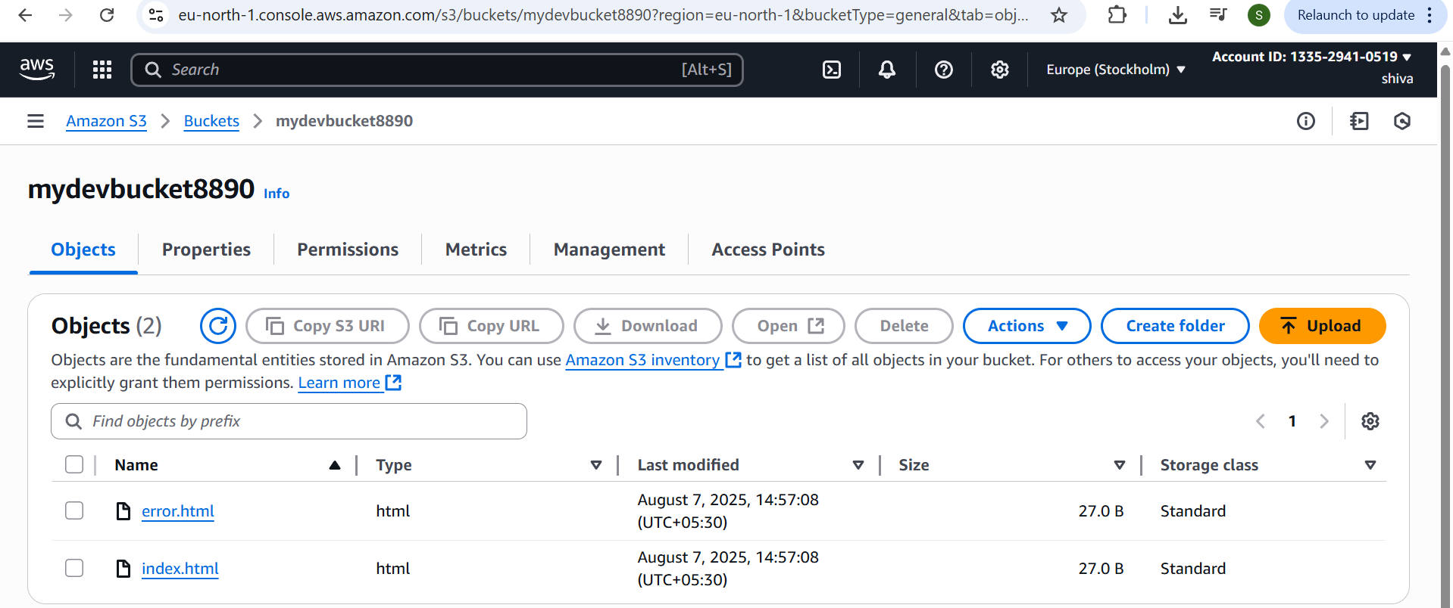

3) Enable cross region replication on s3 buckets.

Create two buckets in different regions.

Give permissions to:  
- Enable versioning  
-create IAM roles  
-configure replica rules  
S3 buckets replication  
S3 ---> Buckets ----> select your bucket ---> Management

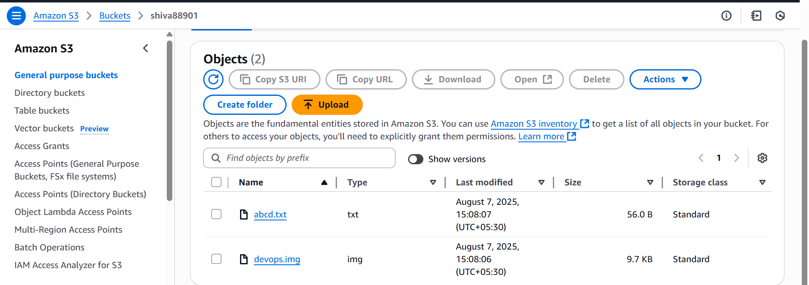

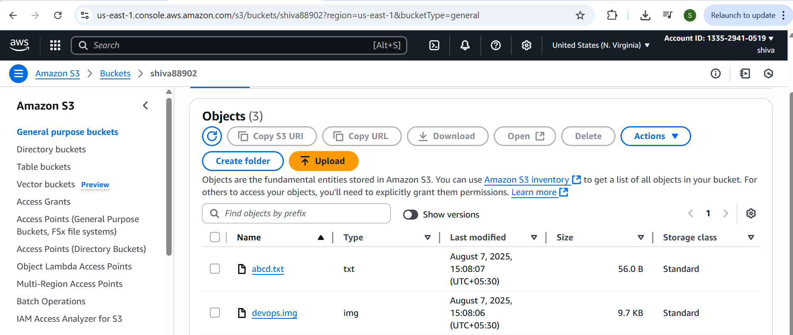

4) Configure bucket policy,only Admin user can see the objects of s3 bucket.

Configure bucket policy to Admin user  
S3 ---> Buckets ---> select created bucket ---> permission ---> edit  
Bucket policy ---> click save changes

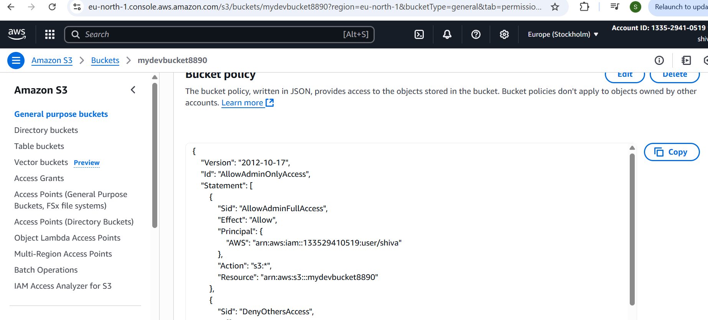

5) Setup lifecycle policies to automatically transition or delete objects based on specific criteria.

Amazon s3 ---> Buckets ---> select created bucket ---> Management  
---> click Create lifecycle rule

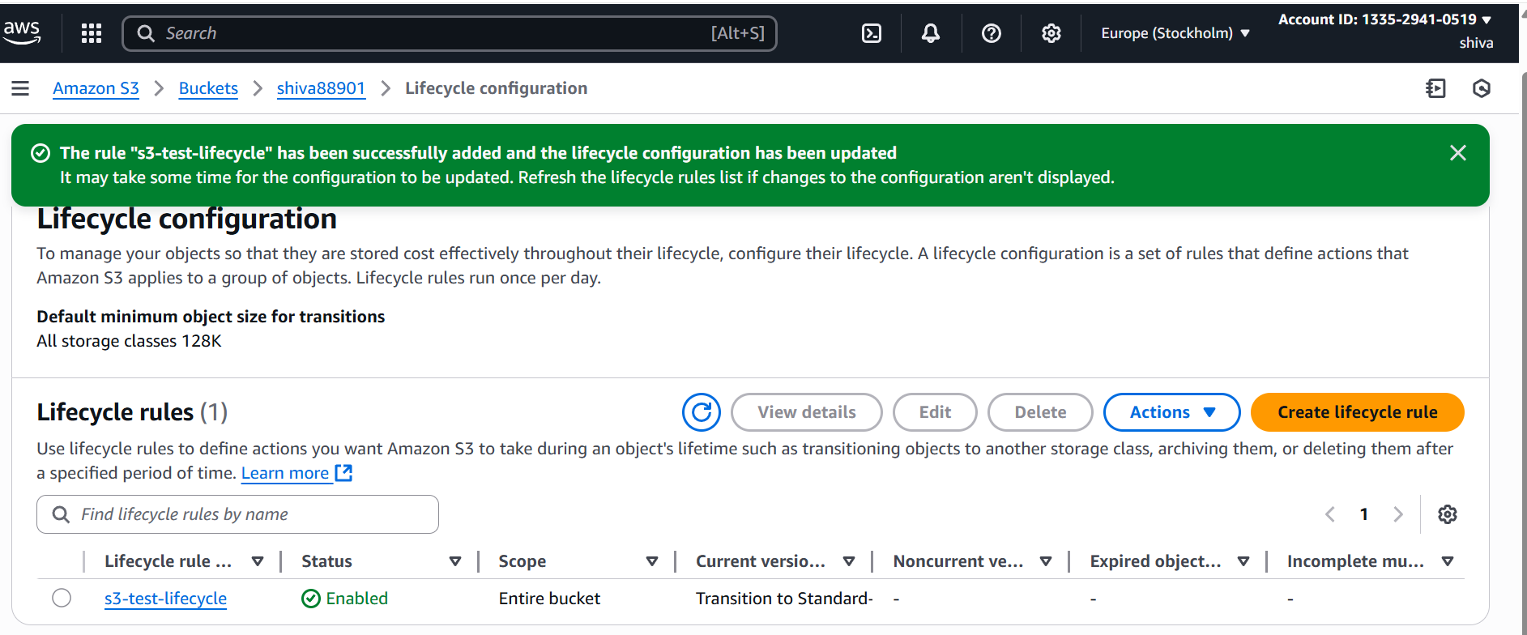

6) Push some objects in s3 using AWS CLI.

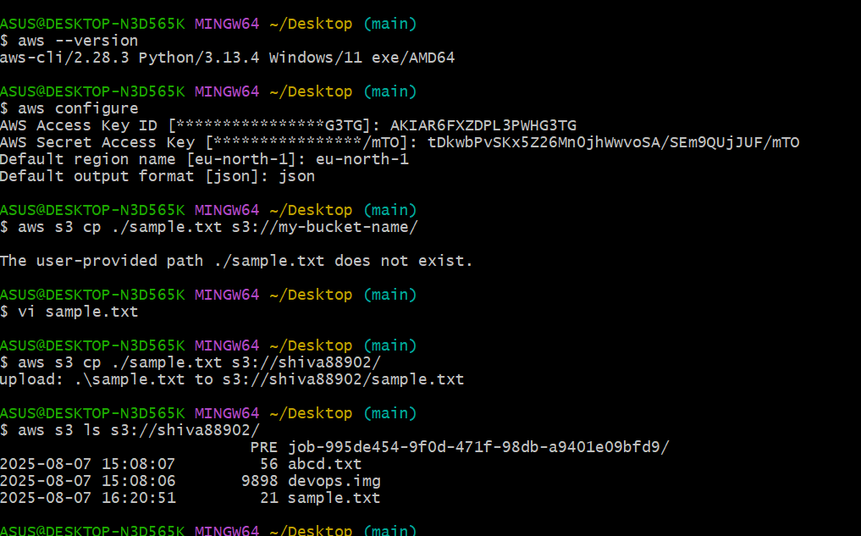

7) Write a bash script to create s3 bucket.

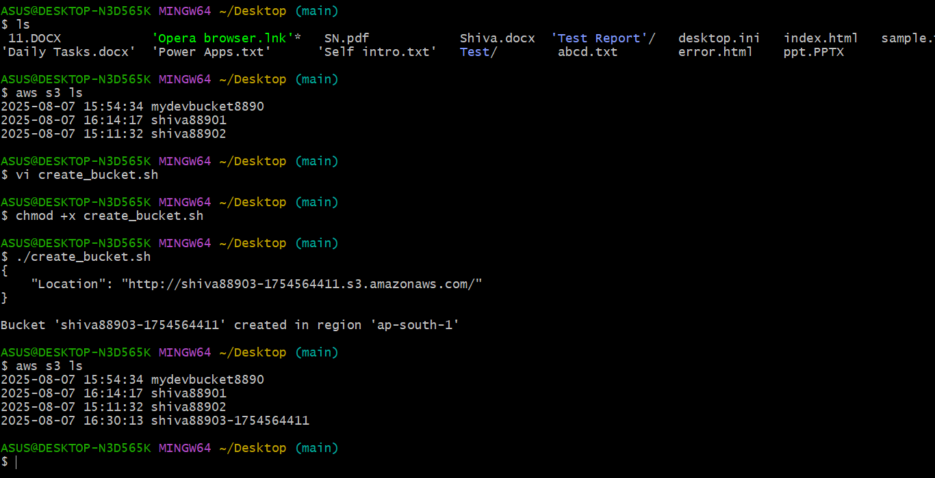

8) Upload one 1 gb of file to s3 using cli.

